DATA ENGINEERING PRACTICALS

Practical-1
Q.no.1-Write programs to parse text files ,CSV,Html, XML and JSON documents and extract relevant data .After retrieving data check any anomalies in the data, missing values etc.

Aim: To write Python programs to parse and extract relevant data from Text, CSV, HTML, XML, and JSON files, and to identify anomalies such as missing values, duplicate records, invalid values, and inconsistent data.

Code:

import pandas as pd

import json

import xml.etree.ElementTree as ET

from bs4 import BeautifulSoup

import re

import os

# Common function to check data for anomalies

def check_anomalies(df, name="Data"):

print(f"\n{'=' * 60}")

print(f"ANOMALY CHECK: {name}")

print(f"{'=' * 60}")

# Missing values

print("\n1. Missing Values:")

missing = df.isnull().sum()

if missing.sum() == 0:

print("No missing values found.")

else:

print(missing[missing > 0])

# Duplicate rows

print("\n2. Duplicate Records:")

duplicates = df.duplicated().sum()

print("Number of duplicate records:", duplicates)

# Empty strings

print("\n3. Empty String Values:")

empty_values = (df.astype(str).apply(lambda x: x.str.strip() == "").sum())

if empty_values.sum() == 0:

print("No empty string values found.")

else:

print(empty_values[empty_values > 0])

# Numeric columns - negative values

print("\n4. Negative Numeric Values:")

numeric_columns = df.select_dtypes(include="number").columns

for column in numeric_columns:

negative = (df[column] < 0).sum()

if negative > 0:

print(f"{column}: {negative} negative values")

# Display summary

print("\n5. Data Summary:")

print(df.describe(include="all"))

# ---------------------------------------------------------

# 1. Parse TEXT file

# ---------------------------------------------------------

def parse_text_file(filename):

print("\n\n===== TEXT FILE =====")

records = []

with open(filename, "r", encoding="utf-8") as file:

for line_number, line in enumerate(file, start=1):

line = line.strip()

if not line:

continue

# Example format:

# Name: John, Age: 25, City: Mumbai

fields = {}

for item in line.split(","):

if ":" in item:

key, value = item.split(":", 1)

fields[key.strip()] = value.strip()

if fields:

records.append(fields)

df = pd.DataFrame(records)

print("\nExtracted Data:")

print(df)

check_anomalies(df, "Text File")

return df

# 2. Parse CSV file

def parse_csv_file(filename):

print("\n\n===== CSV FILE =====")

try:

df = pd.read_csv(filename)

print("\nExtracted Data:")

print(df)

check_anomalies(df, "CSV File")

return df

except Exception as e:

print("Error reading CSV:", e)

return None

# 3. Parse HTML file

def parse_html_file(filename):

print("\n\n===== HTML FILE =====")

with open(filename, "r", encoding="utf-8") as file:

html = file.read()

soup = BeautifulSoup(html, "html.parser")

records = []

# Extract HTML tables

tables = soup.find_all("table")

for table in tables:

rows = table.find_all("tr")

headers = []

for row_index, row in enumerate(rows):

cells = row.find_all(["th", "td"])

values = [cell.get_text(strip=True) for cell in cells]

if row_index == 0:

headers = values

else:

if values:

if headers and len(values) == len(headers):

records.append(dict(zip(headers, values)))

if records:

df = pd.DataFrame(records)

print("\nExtracted Data:")

print(df)

check_anomalies(df, "HTML File")

return df

print("No table data found in HTML file.")

return None

Output:

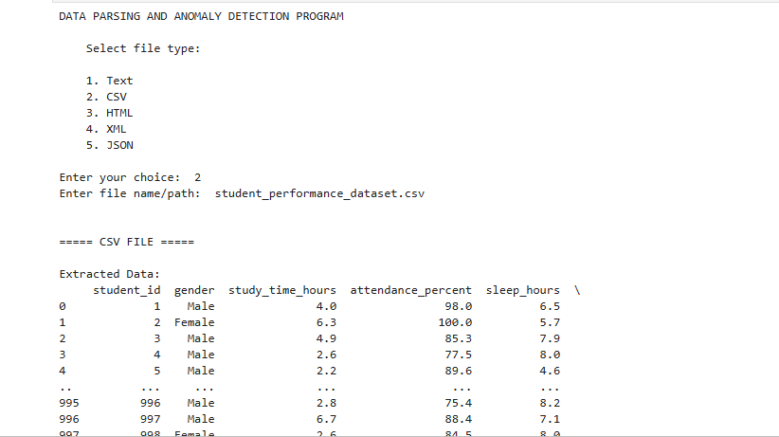

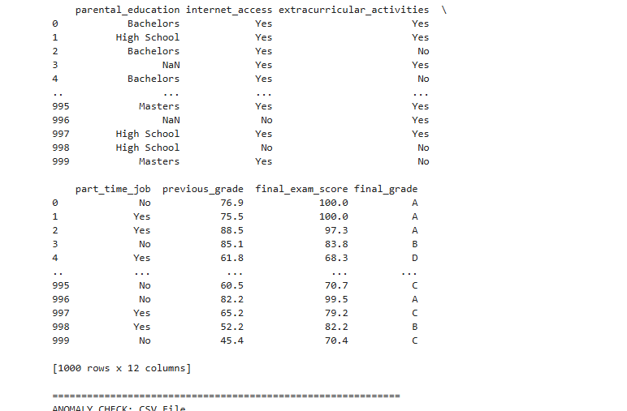

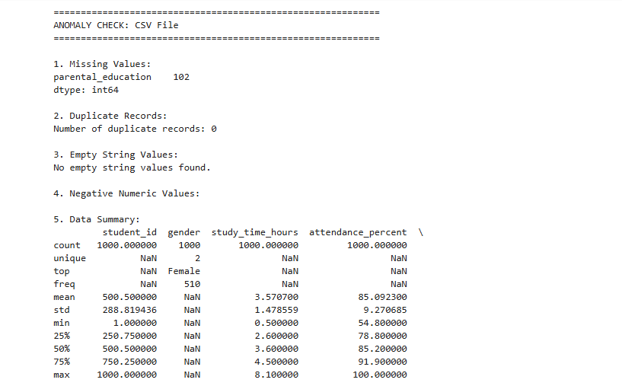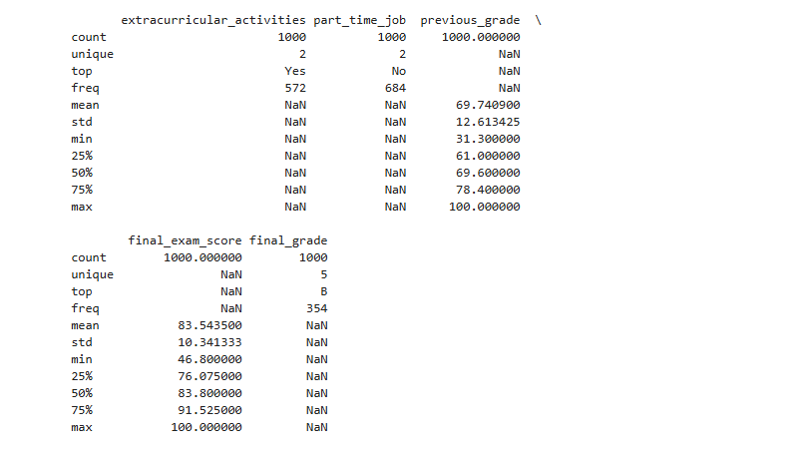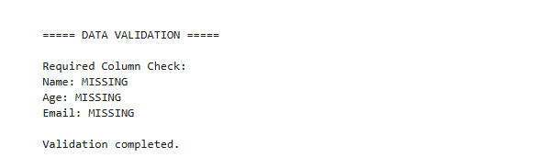

Q.no.2-Write programs for reading and writing binary files.

Aim:To write Python programs for reading data from and writing data to binary files using file handling operations.

Program: Read and Write a Binary File

# Writing data to a binary file

data = b"Hello, this is binary file data."

with open("sample.bin", "wb") as file:

file.write(data)

print("Data written successfully.")

# Reading data from the binary file

with open("sample.bin", "rb") as file:

data = file.read()

print("Data read from binary file:")

print(data)

# Convert bytes to string

print("Decoded data:")

print(data.decode())

Output:

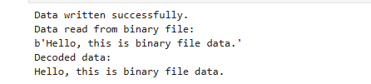

Q.no.3- Write prog for searching ,splitting , and replacing strings based on pattern matching using regular expression

Aim
To write a Python program for searching, splitting, and replacing strings based on pattern matching using regular expressions.

Program

import re

text = "My email is john@gmail.com and my phone number is 9876543210."

# 1. Searching using regular expression

pattern = r"\b[\w.-]+@[\w.-]+\.\w+\b"

match = re.search(pattern, text)

if match:

print("Email found:", match.group())

else:

print("Email not found")

# 2. Splitting using regular expression

sentence = "Python,Java;C++:HTML"

result = re.split(r"[,;:]", sentence)

print("\nAfter splitting:")

print(result)

# 3. Replacing using regular expression

new_text = re.sub(r"\d", "*", text)

print("\nAfter replacing digits:")

print(new_text)

# 4. Parse XML file

def parse_xml_file(filename):

print("\n\n===== XML FILE =====")

tree = ET.parse(filename)

root = tree.getroot()

records = []

# Assumes XML contains repeated child elements such as:

# <students>

# <name>John</name>

# <age>20</age>

# </student>

# </students>

for item in root:

record = {}

for child in item:

record[child.tag] = child.text

if record:

records.append(record)

df = pd.DataFrame(records)

print("\nExtracted Data:")

print(df)

check_anomalies(df, "XML File")

return df

# 5. Parse JSON file

def parse_json_file(filename):

print("\n\n===== JSON FILE =====")

with open(filename, "r", encoding="utf-8") as file:

data = json.load(file)

# JSON may contain either:

# [

# {"name": "John", "age": 20},

# {"name": "Alice", "age": 22}

# ]

#

# or:

# {"students": [...]}

if isinstance(data, dict):

# Find the first list inside the JSON object

list_data = None

for value in data.values():

if isinstance(value, list):

list_data = value

break

if list_data is not None:

data = list_data

else:

data = [data]

df = pd.json_normalize(data)

print("\nExtracted Data:")

print(df)

check_anomalies(df, "JSON File")

return df

# Additional validation

def validate_data(df):

print("\n\n===== DATA VALIDATION =====")

# Check required columns

required_columns = ["Name", "Age", "Email"]

print("\nRequired Column Check:")

for column in required_columns:

if column in df.columns:

print(f"{column}: Found")

else:

print(f"{column}: MISSING")

# Check email format

if "Email" in df.columns:

print("\nInvalid Email Addresses:")

email_pattern = r"^[\w\.-]+@[\w\.-]+\.\w+$"

for index, email in df["Email"].items():

if pd.notna(email):

if not re.match(email_pattern, str(email)):

print(f"Row {index}: {email}")

# Check age

if "Age" in df.columns:

print("\nInvalid Age Values:")

for index, age in df["Age"].items():

try:

age = float(age)

if age < 0 or age > 120:

print(f"Row {index}: Invalid age = {age}")

except (ValueError, TypeError):

print(f"Row {index}: Non-numeric age = {age}")

print("\nValidation completed.")

# Main program

def main():

print("DATA PARSING AND ANOMALY DETECTION PROGRAM")

print("""

Select file type:

1. Text

2. CSV

3. HTML

4. XML

5. JSON

""")

choice = input("Enter your choice: ")

filename = input("Enter file name/path: ")

if not os.path.exists(filename):

print("File does not exist.")

return

if choice == "1":

df = parse_text_file(filename)

elif choice == "2":

df = parse_csv_file(filename)

elif choice == "3":

df = parse_html_file(filename)

elif choice == "4":

df = parse_xml_file(filename)

elif choice == "5":

df = parse_json_file(filename)

else:

print("Invalid choice.")

return

if df is not None and not df.empty:

validate_data(df)

if __name__ == "__main__":

main
Output:
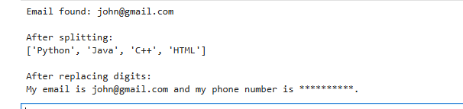
Q.no.4- Design a relational database for a small app and populate the database. Using sql do the CRUD (create , read, updated and delete) operation.

Practical 2
Aim
To implement an ETL workflow using SQLite by extracting raw product data, transforming it into processed product data, calculating total sales, and performing category-wise and city-wise sales analysis.
Code
import sqlite3
import os
# Define the database file name
db_file = 'BI_ETL_Practical2.db'
cnxn = None
try:
# Connect to SQLite database (creates the file if it doesn't exist)
cnxn = sqlite3.connect(db_file)
cursor = cnxn.cursor()
print(f"Successfully connected to SQLite database: {db_file}")
# Optionally, clear existing tables for a fresh run if the file already exists
# (Uncomment if you want to always start with a clean slate)
# cursor.execute("DROP TABLE IF EXISTS Processed_Product_Data;")
# cursor.execute("DROP TABLE IF EXISTS Raw_Product_Data;")
# cnxn.commit()
# print("Existing tables dropped (if any).")
except sqlite3.Error as ex:
print(f"Error connecting to SQLite database: {ex}")
cnxn = None
# Ensure connection is established before proceeding
if cnxn is None:
raise Exception("Failed to establish database connection.")
Output
Successfully connected to SQLite database: BI_ETL_Practical2.db
if cnxn:
cursor = cnxn.cursor()
try:
# Step 2: Create Staging Table
cursor.execute("""
CREATE TABLE IF NOT EXISTS Raw_Product_Data
(
ProductID INTEGER,
ProductName VARCHAR(100),
Category VARCHAR(50),
Quantity INTEGER,
Price DECIMAL(10,2),
SaleDate VARCHAR(20),
City VARCHAR(50)
);
""")
print("Raw_Product_Data table created or already exists.")
# Step 3: Extract / Insert Raw Data
# Check if data already exists to prevent duplicate inserts on re-run
cursor.execute("SELECT COUNT(*) FROM Raw_Product_Data;")
if cursor.fetchone()[0] == 0:
cursor.execute("""
INSERT INTO Raw_Product_Data
(ProductID, ProductName, Category, Quantity, Price, SaleDate, City)
VALUES
(101, 'Laptop', 'Electronics', 2, 55000, '2026-01-10', 'Mumbai'),
(102, 'Mobile', 'Electronics', 3, 25000, '2026-01-12', 'Pune'),
(103, 'Chair', 'Furniture', 5, 4500, '2026-01-15', 'Nashik'),
(104, 'Table', 'Furniture', 2, 8000, '2026-01-18', 'Mumbai'),
(105, 'Headphones', 'Electronics', 4, 2000, '2026-01-20', 'Nagpur');
""")
print("Data inserted into Raw_Product_Data.")
else:
print("Raw_Product_Data already contains data. Skipping insert.")
# Step 4: Display Raw Data (using fetchall() and pandas for better display)
cursor.execute("SELECT * FROM Raw_Product_Data;")
raw_data = cursor.fetchall()
import pandas as pd
raw_df = pd.DataFrame.from_records(raw_data, columns=[desc[0] for desc in cursor.description])
print("\nRaw Product Data:")
display(raw_df)
# Step 5: Create Final Table
cursor.execute("""
CREATE TABLE IF NOT EXISTS Processed_Product_Data
(
ProductID INTEGER PRIMARY KEY,
ProductName VARCHAR(100),
Category VARCHAR(50),
Quantity INTEGER,
Price DECIMAL(10,2),
SaleDate DATE,
City VARCHAR(50),
TotalAmount DECIMAL(12,2)
);
""")
print("Processed_Product_Data table created or already exists.")
# Step 6: Transform and Load Data
# The date is converted from VARCHAR to DATE, and the total amount is calculated.
# Check if data already exists to prevent duplicate inserts on re-run
cursor.execute("SELECT COUNT(*) FROM Processed_Product_Data;")
if cursor.fetchone()[0] == 0:
cursor.execute("""
INSERT INTO Processed_Product_Data
(
ProductID,
ProductName,
Category,
Quantity,
Price,
SaleDate,
City,
TotalAmount
)
SELECT
ProductID,
ProductName,
Category,
Quantity,
Price,
DATE(SaleDate), -- Changed CONVERT(DATE, SaleDate) to DATE(SaleDate) for SQLite
City,
Quantity * Price
FROM Raw_Product_Data;
""")
print("Data transformed and loaded into Processed_Product_Data.")
else:
print("Processed_Product_Data already contains data. Skipping transform and load.")
# Step 7: Display Final Transformed Data
cursor.execute("SELECT * FROM Processed_Product_Data;")
processed_data = cursor.fetchall()
processed_df = pd.DataFrame.from_records(processed_data, columns=[desc[0] for desc in cursor.description])
print("\nProcessed Product Data:")
display(processed_df)
# Step 8: Perform Analysis
print("\nPerforming Analysis:")
# Total Sales
cursor.execute("SELECT SUM(TotalAmount) AS Total_Sales FROM Processed_Product_Data;")
total_sales = cursor.fetchone()[0]
print(f"Total Sales: {total_sales}")
# Category-wise Sales
cursor.execute("""
SELECT
Category,
SUM(TotalAmount) AS Category_Total
FROM Processed_Product_Data
GROUP BY Category;
""")
category_sales = cursor.fetchall()
category_sales_df = pd.DataFrame.from_records(category_sales, columns=[desc[0] for desc in cursor.description])
print("\nCategory-wise Sales:")
display(category_sales_df)
# City-wise Sales
cursor.execute("""
SELECT
City,
SUM(TotalAmount) AS City_Total
FROM Processed_Product_Data
GROUP BY City;
""")
city_sales = cursor.fetchall()
city_sales_df = pd.DataFrame.from_records(city_sales, columns=[desc[0] for desc in cursor.description])
print("\nCity-wise Sales:")
display(city_sales_df)
cnxn.commit() # Commit all transactions
print("All SQL operations completed successfully and committed.")
except sqlite3.Error as ex:
print(f"Error during SQL execution: {ex}")
cnxn.rollback() # Rollback in case of error
print("Transaction rolled back.")
finally:
cursor.close()
cnxn.close()
print("Database connection closed.")
else:
print("No active database connection to execute SQL queries.")
Output
Raw_Product_Data table created or already exists.
Data inserted into Raw_Product_Data.
Raw Product Data:
Processed_Product_Data table created or already exists.
Data transformed and loaded into Processed_Product_Data.
Processed Product Data:
Performing Analysis:
Total Sales: 231500
Category-wise Sales:
City-wise Sales:
All SQL operations completed successfully and committed.
Database connection closed.
Result
Raw product data was staged, transformed into processed data, and analyzed for total sales, category-wise sales, and city-wise sales.

PRACTICAL 3
Aim: Create a collection named products in MongoDB, insert at least three documents with product details like name, price, and stock, and then display all the stored documents using the find method.

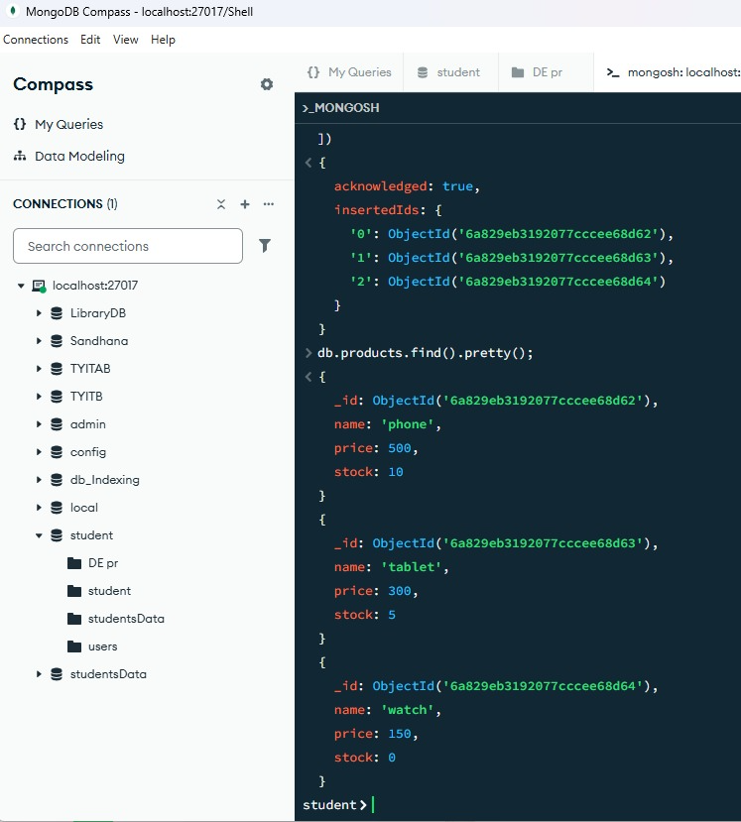

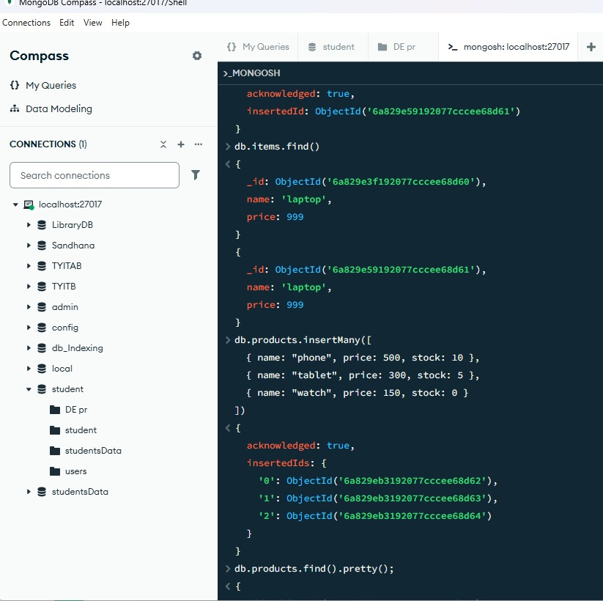

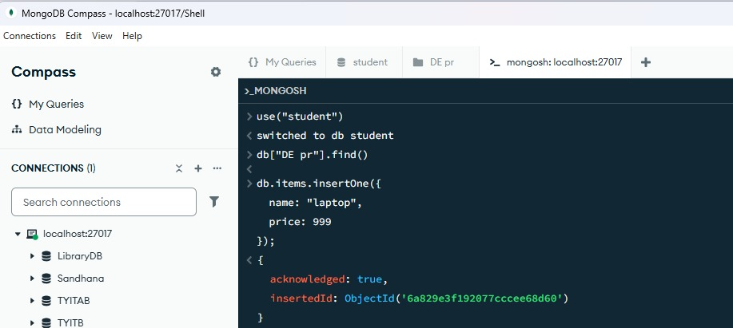
Practical : 4
QUE: Python program demonstrating Noise Elimination, Feature Selection, and Exploratory Data Analysis (EDA) using Pandas, NumPy, Matplotlib, and Scikit-learn

import pandas as pd
data = { 'Age': [20, 21, 22, 23, 24, 100],
'Marks': [75, 80, 85, 90, 95, 20],
'Attendance': [85, 88, 90, 92, 94, 50],
'Constant': [1, 1, 1, 1, 1, 1]}
df = pd.DataFrame(data)
print("Original Dataset:")
print(df)
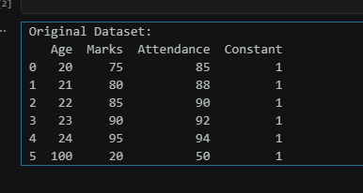
Q1 = df['Age'].quantile(0.25)
Q3 = df['Age'].quantile(0.75)
IQR = Q3 - Q1
lower = Q1 - 1.5 * IQR
upper = Q3 + 1.5 * IQR
df_clean = df[(df['Age'] >= lower) & (df['Age'] <= upper)]
print("\nDataset after Noise Elimination:")
print(df_clean)
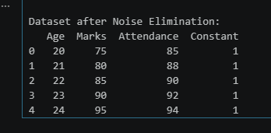
from sklearn.feature_selection import VarianceThreshold
selector = VarianceThreshold(threshold=0.0)
selected = selector.fit_transform(df_clean)
selected_columns = df_clean.columns[selector.get_support()]
print("Selected columns:")
print(selected_columns)
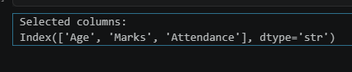
print("\nDataset Information:")
print(df_clean.info())
print("\nStatistical Summary:")
print(df_clean.describe())
print("\nCorrelation Matrix:")
print(df_clean.corr())
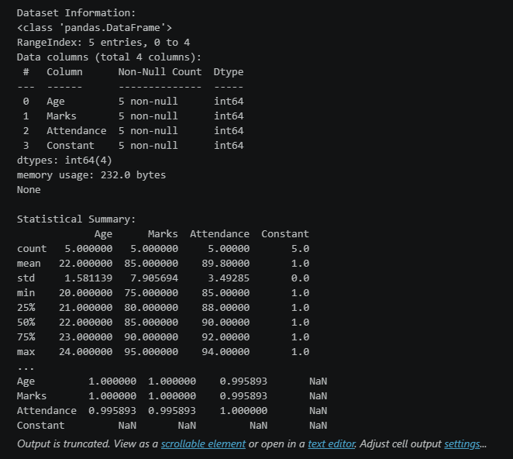

import matplotlib.pyplot as plt
df_clean.hist(figsize=(8, 6))
plt.suptitle("Histogram of Features")
plt.show()
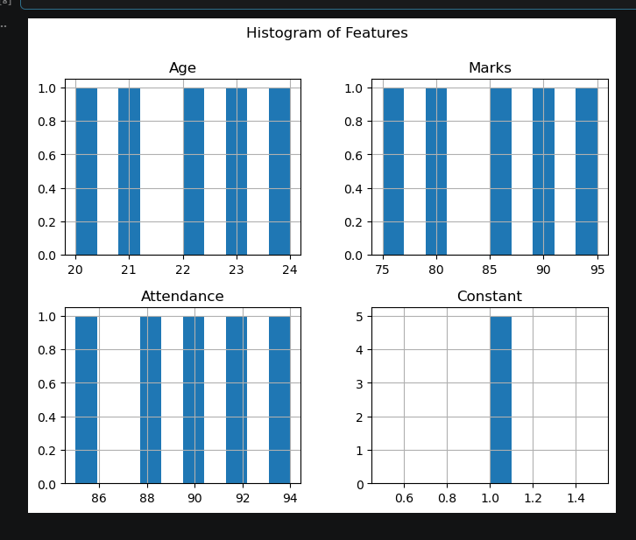

df_clean.boxplot(figsize=(8,5))
plt.title("Boxplot of Dataset")
plt.show()
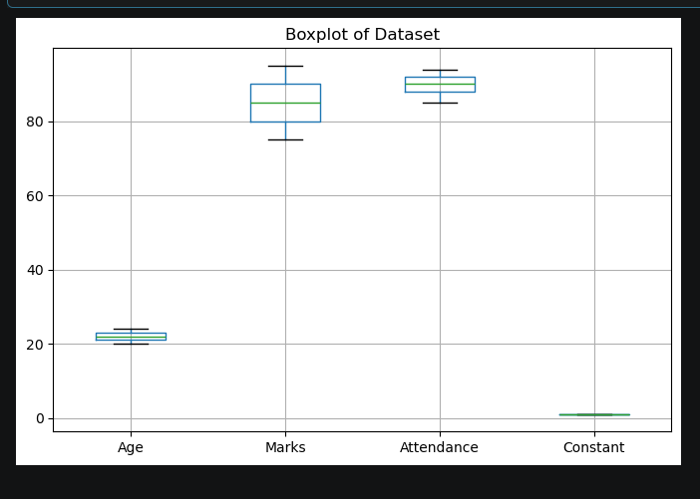

Practical : 5
Que : Extracting Data from APIs and Flat Files Using Python1. ObjectiveWrite a Python script to fetch user data from a public REST API, clean it, and merge it with a flat CSV file containing location details.2. Code ImplementationCreate a script named data_extraction.py:pythonimport pandas as pd import requests

Code :
import pandas as pd
import requests
def extract_api_data(url):
try:
response = requests.get(url, timeout=10)
response.raise_for_status()
data = response.json()
return pd.json_normalize(data)
except requests.exceptions.RequestException as e:
print(f"API Error: {e}")
return pd.DataFrame()
def extract_csv_data(file_path):
try:
return pd.read_csv(file_path)
except FileNotFoundError as e:
print(f"File Error: {e}")
return pd.DataFrame()
api_url = "https://jsonplaceholder.typicode.com/users"
api_df = extract_api_data(api_url)
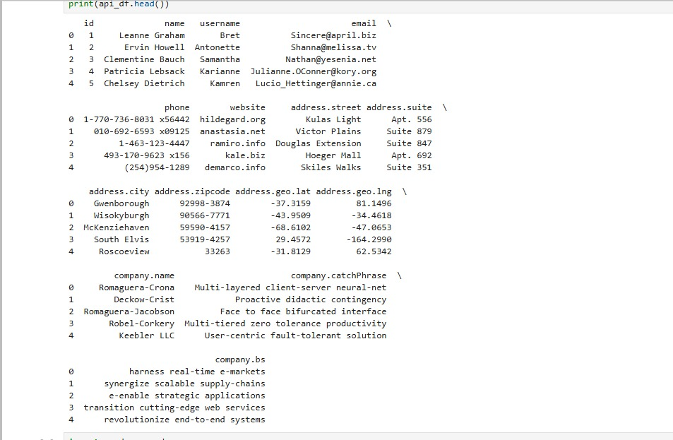

api_df = api_df[["id", "name", "email", "company.name"]]
api_df.rename(
columns={"company.name": "company"},
inplace=True)
print("Cleaned API Data:")
print(api_df)
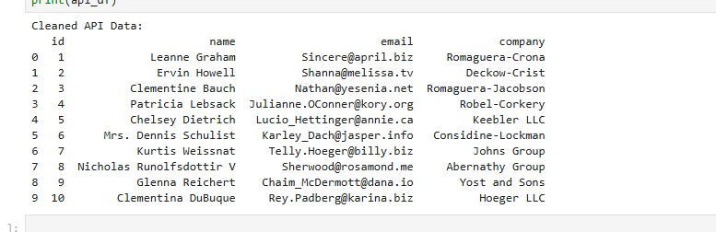
csv_file = "locations.csv"
location_data = {
"id": [1, 2, 3, 4, 5, 6, 7, 8, 9, 10],
"city": [
"New York",
"London",
"Paris",
"Tokyo",
"Berlin",
"Delhi",
"Sydney",
"Moscow",
"Cairo",
"Beijing” ],
"country": [
"USA",
"UK",
"France",
"Japan",
"Germany",
"India",
"Australia",
"Russia",
"Egypt",
"China"]
}
pd.DataFrame(location_data).to_csv(csv_file, index=False)
print("locations.csv created successfully!")
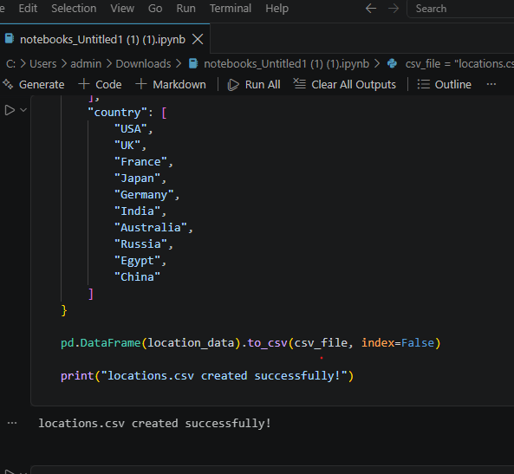

csv_df = extract_csv_data(csv_file)
print("Location Data:")
print(csv_df)
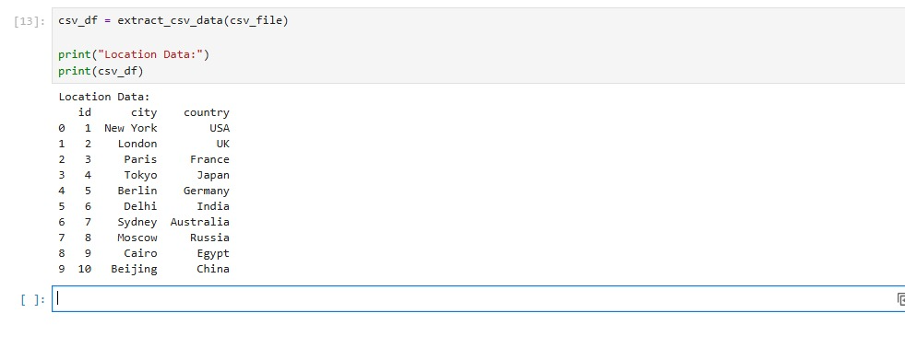
merged_df = pd.merge(
api_df,
csv_df,
on="id",
how="inner")
print("--- Merged ETL Pipeline Data View ---")
print(merged_df)
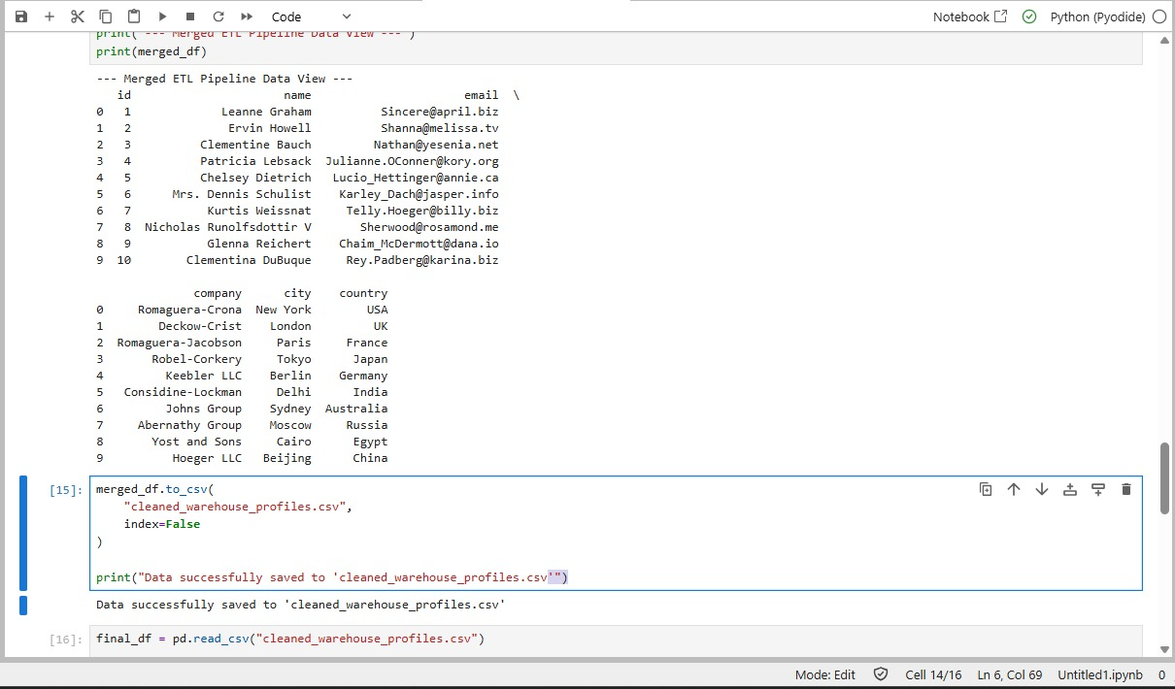

final_df = pd.read_csv("cleaned_warehouse_profiles.csv")
print(final_df)
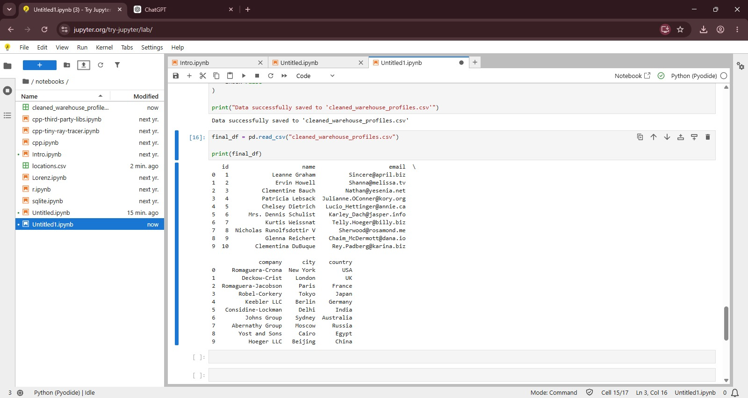

Practical 6
Aim
To configure an Apache Airflow Directed Acyclic Graph (DAG) that runs daily and executes sequential tasks for starting the pipeline, running a data-extraction script, and logging successful completion.
Code
#Que: Setting up Apache Airflow and Creating a DAG1. ObjectiveConfigure a Directed Acyclic Graph (DAG) in Apache Airflow to run daily, executing s
equential dependency tasks: a start notifier, an extraction script, and a pipeline success logger.2. DAG ImplementationPlace this code in your Airflow DAGs directory (usually ~/airflow/dags/data_pipeline_dag.py):pythonfrom datetime import datetime, timedelta
from datetime import datetime, timedelta
# Install required packages, including explicit installation of rfc3987
!pip install --upgrade pip
!pip install rfc3987 apache-airflow --upgrade
from airflow import DAG
from airflow.operators.bash import BashOperator
from airflow.operators.empty import EmptyOperator
# Default arguments
default_args = {
"owner": "data_engineering_lab",
"depends_on_past": False,
"start_date": datetime(2026, 1, 1),
"email_on_failure": False,
"email_on_retry": False,
"retries": 1,
"retry_delay": timedelta(minutes=5),
}
# Define DAG
with DAG(
dag_id="university_etl_orchestration",
default_args=default_args,
description="Daily ETL pipeline orchestration",
schedule=timedelta(days=1),
catchup=False,
) as dag:
# Task 1: Start pipeline
start_pipeline = EmptyOperator(
task_id="start_pipeline"
)
# Task 2: Run extraction script
execute_extraction = BashOperator(
task_id="run_extraction_script",
bash_command="python3 /home/$USER/airflow/dags/data_extraction.py",
)
# Task 3: Log successful completion
pipeline_complete = BashOperator(
task_id="log_pipeline_success",
bash_command='echo "ETL Execution completed successfully at $(date)"',
)
# Task dependencies
start_pipeline >> execute_extraction >> pipeline_complete
Output
Successfully installed pip-26.2.1
2026-10-01T08:49:45.803200Z [warning ] The `airflow.operators.bash.BashOperator` attribute is deprecated. Please use `'airflow.providers.standard.operators.bash.BashOperator'`. [py.warnings] category=DeprecatedImportWarning filename=/tmp/ipykernel_2824/3822651003.py lineno=9
2026-10-01T08:49:45.810016Z [warning ] The `airflow.operators.empty.EmptyOperator` attribute is deprecated. Please use `'airflow.providers.standard.operators.empty.EmptyOperator'`. [py.warnings] category=DeprecatedImportWarning filename=/tmp/ipykernel_2824/3822651003.py lineno=10
from datetime import datetime
print("Starting data extraction...")
data = [
{"id": 1, "name": "Student A"},
{"id": 2, "name": "Student B"},
{"id": 3, "name": "Student C"}
]
print("Extracted data:")
for record in data:
print(record)
print("Extraction completed successfully.")
print("Execution time:", datetime.now())
Output
Starting data extraction...
Extracted data:
{'id': 1, 'name': 'Student A'}
{'id': 2, 'name': 'Student B'}
{'id': 3, 'name': 'Student C'}
Extraction completed successfully.
Execution time: 2026-10-01 08:51:26.983305
from datetime import datetime, timedelta
from airflow import DAG
from airflow.operators.bash import BashOperator
from airflow.operators.empty import EmptyOperator
default_args = {
"owner": "data_engineering_lab",
"depends_on_past": False,
"start_date": datetime(2026, 1, 1),
"email_on_failure": False,
"email_on_retry": False,
"retries": 1,
"retry_delay": timedelta(minutes=5),
}
with DAG(
dag_id="university_etl_orchestration",
default_args=default_args,
description="Daily ETL pipeline orchestration",
schedule=timedelta(days=1),
catchup=False,
) as dag:
start_pipeline = EmptyOperator(
task_id="start_pipeline"
)
execute_extraction = BashOperator(
task_id="run_extraction_script",
bash_command="python3 /home/$USER/airflow/dags/data_extraction.py",
)
pipeline_complete = BashOperator(
task_id="log_pipeline_success",
bash_command='echo "ETL Execution completed successfully at $(date)"',
)
start_pipeline >> execute_extraction >> pipeline_complete
Output
2026-10-01T08:51:47.868897Z [warning ] The `airflow.operators.bash.BashOperator` attribute is deprecated. Please use `'airflow.providers.standard.operators.bash.BashOperator'`. [py.warnings] category=DeprecatedImportWarning filename=/tmp/ipykernel_3460/2383551127.py lineno=4
2026-10-01T08:51:47.875607Z [warning ] The `airflow.operators.empty.EmptyOperator` attribute is deprecated. Please use `'airflow.providers.standard.operators.empty.EmptyOperator'`. [py.warnings] category=DeprecatedImportWarning filename=/tmp/ipykernel_3460/2383551127.py lineno=5
from datetime import datetime
print("======================================")
print(" DATA EXTRACTION STARTED")
print("======================================")
# Sample data
data = [
{"id": 1, "name": "Student A"},
{"id": 2, "name": "Student B"},
{"id": 3, "name": "Student C"}
]
print("Extracting data...")
for record in data:
print(record)
print("Data extraction completed successfully.")
print("Execution time:", datetime.now())
print("======================================")
print(" DATA EXTRACTION COMPLETED")
print("======================================")
Output
DATA EXTRACTION STARTED
Extracting data...
{'id': 1, 'name': 'Student A'}
{'id': 2, 'name': 'Student B'}
{'id': 3, 'name': 'Student C'}
Data extraction completed successfully.
Execution time: 2026-10-01 08:51:56.002598
DATA EXTRACTION COMPLETED
Practical 7
Aim
To implement ETL pipelines using CSV and JSON data, including data cleaning, transformation, validation, loading into SQLite databases, removal of invalid records, and incremental data loading.
Code

7.1 ETL Pipeline from CSV to Database
# ETL Pipeline from CSV to Database
import pandas as pd
import sqlite3
# -----------------------------
# EXTRACT
# -----------------------------
data = {
"Name": ["Amit", "Priya", "Rahul", "Sneha", "Karan"],
"Age": [21, 22, None, 23, 25],
"City": ["Mumbai", "Pune", "Mumbai", "Delhi", "Pune"],
"Salary": [30000, 35000, 40000, None, 45000]
}
df = pd.DataFrame(data)
df.to_csv("employees.csv", index=False)
# Read CSV file
df = pd.read_csv("employees.csv")
print("Extracted Data:")
print(df)
# -----------------------------
# TRANSFORM / CLEAN
# -----------------------------
# Fill missing Age with mean
df["Age"] = df["Age"].fillna(df["Age"].mean())
# Fill missing Salary with median
df["Salary"] = df["Salary"].fillna(df["Salary"].median())
# Convert Age to integer
df["Age"] = df["Age"].astype(int)
# Remove duplicate records
df = df.drop_duplicates()
# Create Salary Category
df["Salary_Category"] = df["Salary"].apply(
lambda x: "High" if x >= 40000 else "Low"
)
print("\nTransformed Data:")
print(df)
# -----------------------------
# LOAD
# -----------------------------
conn = sqlite3.connect("etl_database.db")
df.to_sql(
"employees",
conn,
if_exists="replace",
index=False
)
print("\nData successfully loaded into database.")
# Verify
result = pd.read_sql("SELECT * FROM employees", conn)
print("\nDatabase Data:")
print(result)
conn.close()
Output
Extracted Data:
Name Age City Salary
0 Amit 21.0 Mumbai 30000.0
1 Priya 22.0 Pune 35000.0
2 Rahul NaN Mumbai 40000.0
3 Sneha 23.0 Delhi NaN
4 Karan 25.0 Pune 45000.0
Transformed Data:
Name Age City Salary Salary_Category
0 Amit 21 Mumbai 30000.0 Low
1 Priya 22 Pune 35000.0 Low
2 Rahul 22 Mumbai 40000.0 High
3 Sneha 23 Delhi 37500.0 Low
4 Karan 25 Pune 45000.0 High
Data successfully loaded into database.
Database Data:
Name Age City Salary Salary_Category
0 Amit 21 Mumbai 30000.0 Low
1 Priya 22 Pune 35000.0 Low
2 Rahul 22 Mumbai 40000.0 High
3 Sneha 23 Delhi 37500.0 Low
4 Karan 25 Pune 45000.0 High

7.2 Extract Multiple CSV Files and Combine Them
# Extract Multiple CSV Files and Combine Them
import pandas as pd
import sqlite3
# -----------------------------
# CREATE SAMPLE CSV FILES
# -----------------------------
data1 = {
"ID": [1, 2, 3],
"Name": ["Amit", "Priya", "Rahul"],
"Marks": [85, 90, 78]
}
data2 = {
"ID": [4, 5, 6],
"Name": ["Sneha", "Karan", "Neha"],
"Marks": [88, 76, 95]
}
pd.DataFrame(data1).to_csv("students1.csv", index=False)
pd.DataFrame(data2).to_csv("students2.csv", index=False)
# -----------------------------
# EXTRACT
# -----------------------------
df1 = pd.read_csv("students1.csv")
df2 = pd.read_csv("students2.csv")
print("File 1:")
print(df1)
print("\nFile 2:")
print(df2)
# -----------------------------
# TRANSFORM
# -----------------------------
combined_df = pd.concat([df1, df2], ignore_index=True)
# Create result column
combined_df["Result"] = combined_df["Marks"].apply(
lambda x: "Pass" if x >= 40 else "Fail"
)
print("\nCombined Dataset:")
print(combined_df)
# -----------------------------
# LOAD
# -----------------------------
conn = sqlite3.connect("student_database.db")
combined_df.to_sql(
"students",
conn,
if_exists="replace",
index=False
)
print("\nCombined data loaded successfully.")
conn.close()
Output
File 1:
ID Name Marks
0 1 Amit 85
1 2 Priya 90
2 3 Rahul 78
File 2:
ID Name Marks
0 4 Sneha 88
1 5 Karan 76
2 6 Neha 95
Combined Dataset:
ID Name Marks Result
0 1 Amit 85 Pass
1 2 Priya 90 Pass
2 3 Rahul 78 Pass
3 4 Sneha 88 Pass
4 5 Karan 76 Pass
5 6 Neha 95 Pass
Combined data loaded successfully.

7.3 ETL Pipeline for JSON Data
#ETL Pipeline for JSON Data
import json
import pandas as pd
import sqlite3
# -----------------------------
# CREATE SAMPLE JSON DATA
# -----------------------------
json_data = [
{
"id": 1,
"name": "Amit",
"email": "amit@gmail.com",
"address": {
"city": "Mumbai",
"country": "India"
}
},
{
"id": 2,
"name": "Priya",
"email": "priya@gmail.com",
"address": {
"city": "Pune",
"country": "India"
}
}
]
with open("users.json", "w") as file:
json.dump(json_data, file, indent=4)
# -----------------------------
# EXTRACT
# -----------------------------
with open("users.json", "r") as file:
data = json.load(file)
print("Extracted JSON:")
print(data)
# -----------------------------
# TRANSFORM
# -----------------------------
transformed_data = []
for user in data:
transformed_data.append({
"User_ID": user["id"],
"Name": user["name"].upper(),
"Email": user["email"].lower(),
"City": user["address"]["city"],
"Country": user["address"]["country"]
})
df = pd.DataFrame(transformed_data)
print("\nTransformed Data:")
print(df)
# -----------------------------
# LOAD
# -----------------------------
conn = sqlite3.connect("json_database.db")
df.to_sql(
"users",
conn,
if_exists="replace",
index=False
)
print("\nJSON data loaded into relational database.")
# Verify
result = pd.read_sql("SELECT * FROM users", conn)
print("\nDatabase Table:")
print(result)
conn.close()
Output
Extracted JSON:
[{'id': 1, 'name': 'Amit', 'email': 'amit@gmail.com', 'address': {'city': 'Mumbai', 'country': 'India'}}, {'id': 2, 'name': 'Priya', 'email': 'priya@gmail.com', 'address': {'city': 'Pune', 'country': 'India'}}]
Transformed Data:
User_ID Name Email City Country
0 1 AMIT amit@gmail.com Mumbai India
1 2 PRIYA priya@gmail.com Pune India
JSON data loaded into relational database.
Database Table:
User_ID Name Email City Country
0 1 AMIT amit@gmail.com Mumbai India
1 2 PRIYA priya@gmail.com Pune India

7.4 ETL Process to Identify and Remove Invalid Records
#ETL Process to Identify and Remove Invalid Records
import pandas as pd
import sqlite3
# -----------------------------
# EXTRACT
# -----------------------------
data = {
"ID": [1, 2, 3, 4, 5],
"Name": ["Amit", "Priya", "", "Rahul", "Sneha"],
"Age": [21, -5, 25, 200, 23],
"Email": [
"amit@gmail.com",
"priya@gmail.com",
"invalidemail",
"rahul@gmail.com",
"sneha@gmail.com"
]
}
df = pd.DataFrame(data)
print("Original Data:")
print(df)
# -----------------------------
# IDENTIFY INVALID RECORDS
# -----------------------------
invalid = (
(df["Name"] == "") |
(df["Age"] < 0) |
(df["Age"] > 120) |
(~df["Email"].str.contains("@", na=False))
)
invalid_records = df[invalid]
print("\nInvalid Records:")
print(invalid_records)
# -----------------------------
# REMOVE INVALID RECORDS
# -----------------------------
clean_df = df[~invalid].copy()
print("\nClean Data:")
print(clean_df)
# -----------------------------
# LOAD
# -----------------------------
conn = sqlite3.connect("valid_data.db")
clean_df.to_sql(
"valid_users",
conn,
if_exists="replace",
index=False
)
print("\nValid records loaded successfully.")
conn.close()
Output
Original Data:
ID Name Age Email
0 1 Amit 21 amit@gmail.com
1 2 Priya -5 priya@gmail.com
2 3 25 invalidemail
3 4 Rahul 200 rahul@gmail.com
4 5 Sneha 23 sneha@gmail.com
Invalid Records:
ID Name Age Email
1 2 Priya -5 priya@gmail.com
2 3 25 invalidemail
3 4 Rahul 200 rahul@gmail.com
Clean Data:
ID Name Age Email
0 1 Amit 21 amit@gmail.com
4 5 Sneha 23 sneha@gmail.com
Valid records loaded successfully.

7.5 Data Validation Before Loading
#Data Validation Before Loading
import pandas as pd
import sqlite3
# -----------------------------
# EXTRACT
# -----------------------------
data = {
"ID": [1, 2, 3, 4],
"Name": ["Amit", "Priya", "Rahul", "Sneha"],
"Age": [21, 22, 150, 24],
"Email": [
"amit@gmail.com",
"priya@gmail.com",
"rahul@gmail.com",
"invalid-email"
]
}
df = pd.DataFrame(data)
print("Extracted Data:")
print(df)
# -----------------------------
# VALIDATION
# -----------------------------
def validate_record(row):
if row["Age"] < 18 or row["Age"] > 100:
return False
if "@" not in row["Email"]:
return False
if row["Name"] == "":
return False
return True
df["Valid"] = df.apply(validate_record, axis=1)
print("\nValidation Results:")
print(df)
# Separate valid and invalid records
valid_df = df[df["Valid"] == True].drop(columns=["Valid"])
invalid_df = df[df["Valid"] == False].drop(columns=["Valid"])
print("\nValid Records:")
print(valid_df)
print("\nInvalid Records:")
print(invalid_df)
# -----------------------------
# LOAD ONLY VALID DATA
# -----------------------------
conn = sqlite3.connect("validated_database.db")
valid_df.to_sql(
"customers",
conn,
if_exists="replace",
index=False
)
print("\nValidated data loaded successfully.")
conn.close()
Output
Extracted Data:
ID Name Age Email
0 1 Amit 21 amit@gmail.com
1 2 Priya 22 priya@gmail.com
2 3 Rahul 150 rahul@gmail.com
3 4 Sneha 24 invalid-email
Validation Results:
ID Name Age Email Valid
0 1 Amit 21 amit@gmail.com True
1 2 Priya 22 priya@gmail.com True
2 3 Rahul 150 rahul@gmail.com False
3 4 Sneha 24 invalid-email False
Valid Records:
ID Name Age Email
0 1 Amit 21 amit@gmail.com
1 2 Priya 22 priya@gmail.com
Invalid Records:
ID Name Age Email
2 3 Rahul 150 rahul@gmail.com
3 4 Sneha 24 invalid-email
Validated data loaded successfully.

7.6 Incremental Data Loading
#Incremental Data Loading
import pandas as pd
import sqlite3
# -----------------------------
# INITIAL DATA
# -----------------------------
initial_data = {
"ID": [1, 2, 3],
"Name": ["Amit", "Priya", "Rahul"],
"Salary": [30000, 35000, 40000]
}
df_initial = pd.DataFrame(initial_data)
df_initial.to_csv("employees_initial.csv", index=False)
# -----------------------------
# CREATE DATABASE
# -----------------------------
conn = sqlite3.connect("incremental_database.db")
df_initial.to_sql(
"employees",
conn,
if_exists="replace",
index=False
)
print("Initial data loaded:")
print(df_initial)
# -----------------------------
# NEW DATA
# -----------------------------
new_data = {
"ID": [4, 5],
"Name": ["Sneha", "Karan"],
"Salary": [42000, 45000]
}
df_new = pd.DataFrame(new_data)
df_new.to_csv("employees_new.csv", index=False)
print("\nNew data:")
print(df_new)
# -----------------------------
# CHECK EXISTING RECORDS
# -----------------------------
existing_df = pd.read_sql(
"SELECT ID FROM employees",
conn
)
print("\nExisting IDs:")
print(existing_df)
# -----------------------------
# INCREMENTAL LOAD
# -----------------------------
incremental_df = df_new[
~df_new["ID"].isin(existing_df["ID"])
]
if not incremental_df.empty:
incremental_df.to_sql(
"employees",
conn,
if_exists="append",
index=False
)
print("\nNew records inserted:")
print(incremental_df)
else:
print("\nNo new records found.")
# -----------------------------
# FINAL DATABASE
# -----------------------------
final_df = pd.read_sql(
"SELECT * FROM employees",
conn
)
print("\nFinal Database:")
print(final_df)
conn.close()
Output
Initial data loaded:
ID Name Salary
0 1 Amit 30000
1 2 Priya 35000
2 3 Rahul 40000
New data:
ID Name Salary
0 4 Sneha 42000
1 5 Karan 45000
Existing IDs:
ID
0 1
1 2
2 3
New records inserted:
ID Name Salary
0 4 Sneha 42000
1 5 Karan 45000
Final Database:
ID Name Salary
0 1 Amit 30000
1 2 Priya 35000
2 3 Rahul 40000
3 4 Sneha 42000
4 5 Karan 45000
Result
The notebook demonstrates CSV/JSON extraction, transformation, validation and cleaning, SQLite loading, and incremental insertion of new records.

PRACTICAL 8
!pip install pyspark

from pyspark.sql import SparkSession
from pyspark.sql.functions import col, avg, sum, count
spark = SparkSession.builder \
.appName("PySpark Assignment") \
.getOrCreate()

print("Spark started successfully!")



%%writefile sales.csv
Product,Category,Sales,Quantity
Laptop,Electronics,1000,2
Phone,Electronics,500,5
Chair,Furniture,200,4
Table,Furniture,300,2
Laptop,Electronics,1000,2
Headphones,Electronics,150,10
Chair,Furniture,200,4
Book,Stationery,50,20

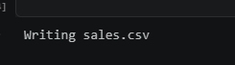

df = spark.read.csv("sales.csv", header=True, inferSchema=True)

df.show()

print("Schema:")
df.printSchema()

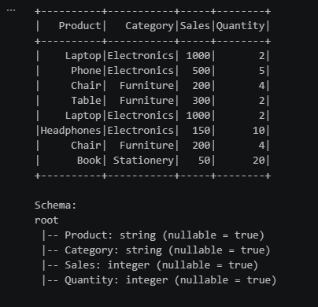

filtered_df = df.filter(col("Sales") > 500)

filtered_df.show()

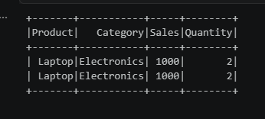

df.filter(df.Sales > 500).show()

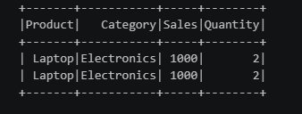

grouped_df = df.groupBy("Category").agg(
sum("Sales").alias("Total_Sales")
)

grouped_df.show()

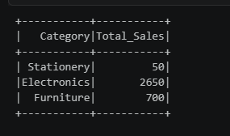

grouped_df = df.groupBy("Category").sum("Sales")

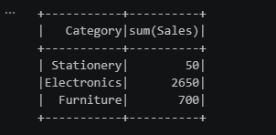

from pyspark.sql import SparkSession
from pyspark.sql.functions import col, avg, sum

spark = SparkSession.builder \
.appName("Sales Analysis") \
.getOrCreate()

df = spark.read.csv(
"sales.csv",
header=True,
inferSchema=True
)

df.show()

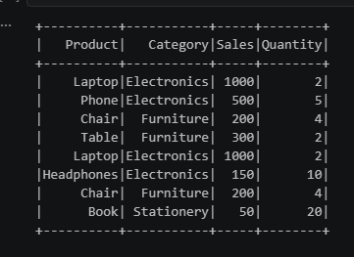

from pyspark.sql.functions import sum

df.groupBy("Category").agg(
sum("Sales").alias("Total_Sales")
).show()

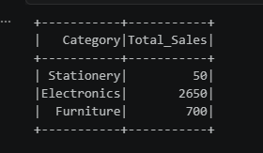

df.dropDuplicates().show()

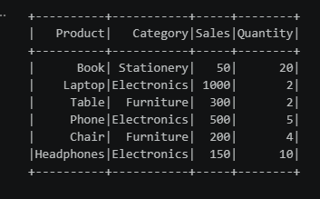

from pyspark.sql.functions import sum, avg

grouped_df = df.groupBy("Category").agg(
sum("Sales").alias("Total_Sales")
)

print("Total Sales by Category:")
grouped_df.show()

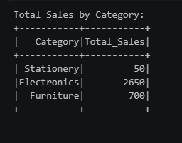

deduplicated_df = df.dropDuplicates()

print("Dataset after removing duplicates:")
deduplicated_df.show()

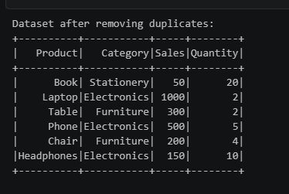

%%writefile product_info.csv
Product,Brand
Laptop,Dell
Phone,Samsung
Chair,IKEA
Table,IKEA
Headphones,Sony
Book,Penguin
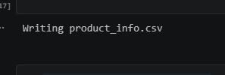

product_df = spark.read.csv(
"product_info.csv",
header=True,
inferSchema=True
)

product_df.show()

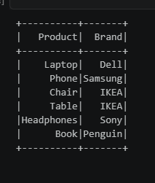

joined_df = df.join(
product_df,
on="Product",
how="inner"
)

print("Joined Dataset:")
joined_df.show()

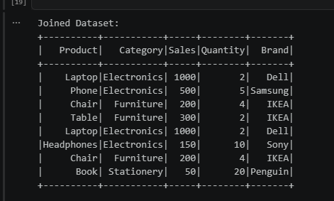

average_sales = df.groupBy("Category").agg(
avg("Sales").alias("Average_Sales")
)

print("Average Sales by Product Category:")
average_sales.show()

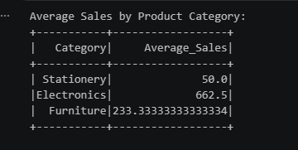

Practical-9
Que: Build an end-to-end pipeline: CSV → Python/Pandas → Data Cleaning → SQL Database → Report.
Build an ETL pipeline for an e-commerce dataset containing customers, orders, products, and payments.
Design a data pipeline that handles both historical and newly arriving data.

- CSV → Pandas → Data Cleaning → SQL Database → Report

import pandas as pd
data = { "Customer": ["John", "Mary", "John", "David", None],
"Product": ["Laptop", "Phone", "Laptop", "Tablet", "Phone"],
"Sales": [1000, 500, 1000, 700, None],
"Quantity": [1, 2, 1, 3, 2]}
df = pd.DataFrame(data)
df.to_csv("sales_data.csv", index=False)
print("CSV created successfully!")
df
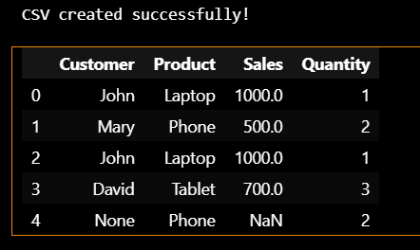

df = pd.read_csv("sales_data.csv")
print("Original Data:")
print(df)
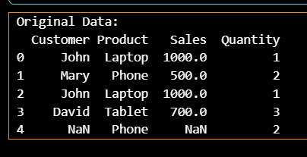

print("Missing values:")
print(df.isnull().sum())
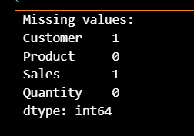

df["Customer"] = df["Customer"].fillna("Unknown")
df["Sales"] = df["Sales"].fillna(df["Sales"].mean())
print("Cleaned Data:")
print(df)
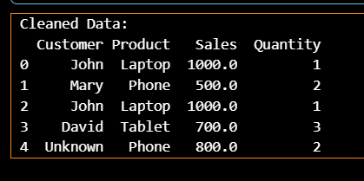

df = df.drop_duplicates()
print("After removing duplicates:")
print(df)
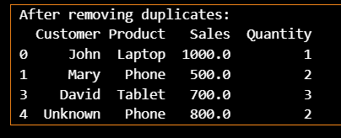

import sqlite3
connection = sqlite3.connect("sales_database.db")
df.to_sql( "sales",
connection,
if_exists="replace",
index=False)
print("Data stored in SQL database successfully!")


query = """
SELECT Product, SUM(Sales) AS Total_Sales
FROM sales
GROUP BY Product
"""
report = pd.read_sql_query(query, connection)
print("Sales Report:")
print(report)
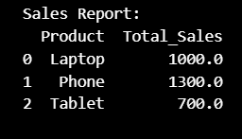

connection.close()
print("Pipeline completed successfully!")


- ETL pipeline for an e-commerce dataset

import pandas as pd
customers = pd.DataFrame({
"customer_id": [1, 2, 3],
"name": ["John", "Mary", "David"],
"email": ["john@gmail.com", "mary@gmail.com", "david@gmail.com"]
})
products = pd.DataFrame({
"product_id": [101, 102, 103],
"product": ["Laptop", "Phone", "Tablet"],
"price": [1000, 500, 700]
})
orders = pd.DataFrame({
"order_id": [1001, 1002, 1003],
"customer_id": [1, 2, 3],
"product_id": [101, 102, 103],
"quantity": [1, 2, 1]
})
payments = pd.DataFrame({
"payment_id": [501, 502, 503],
"order_id": [1001, 1002, 1003],
"payment_status": ["Paid", "Paid", "Pending"]
})
print("Data extracted successfully!")



order_data = orders.merge(
products,
on="product_id"
)

order_data["total_amount"] = (
order_data["price"] * order_data["quantity"])
print("Transformed Order Data:")
print(order_data)
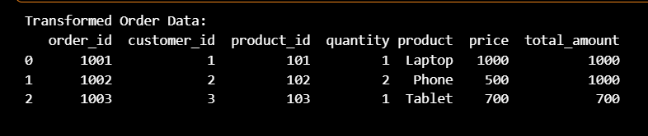

order_data = order_data.merge(
customers,
on="customer_id")
print("Customer + Order Data:")
print(order_data)
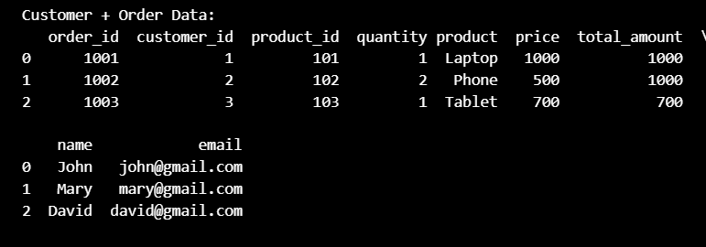

order_data = order_data.merge(
payments,
on="order_id")
print("Complete E-commerce Data:")
print(order_data)
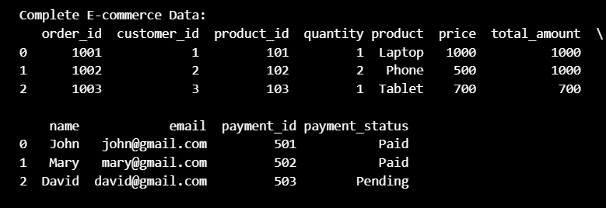
import sqlite3
connection = sqlite3.connect("ecommerce.db")
customers.to_sql(
"customers",
connection,
if_exists="replace",
index=False
)
products.to_sql(
"products",
connection,
if_exists="replace",
index=False
)
orders.to_sql(
"orders",
connection,
if_exists="replace",
index=False
)
payments.to_sql(
"payments",
connection,
if_exists="replace",
index=False
)
order_data.to_sql(
"order_report",
connection,
if_exists="replace",
index=False
)
print("ETL pipeline completed!")
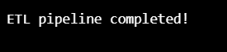

query = """
SELECT product,
SUM(quantity) AS total_quantity,
SUM(total_amount) AS total_sales
FROM order_report
GROUP BY product
"""

report = pd.read_sql_query(query, connection)
print("E-commerce Sales Report:")
print(report)
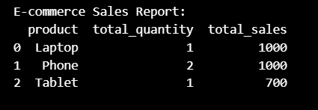

connection.close()

3. Historical + newly arriving data pipeline

import pandas as pd
historical_data = pd.DataFrame({
"order_id": [1, 2, 3],
"customer": ["John", "Mary", "David"],
"sales": [1000, 500, 700]})
historical_data
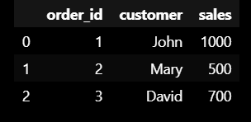

new_data = pd.DataFrame({
"order_id": [4, 5],
"customer": ["Alice", "Bob"],
"sales": [800, 600]})
new_data
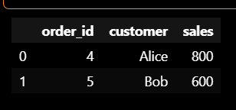

combined_data = pd.concat(
[historical_data, new_data],
ignore_index=True
)

print("Combined Data:")
print(combined_data)
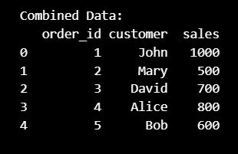

combined_data = combined_data.drop_duplicates(
subset=["order_id"])
print("Data after removing duplicates:")
print(combined_data)
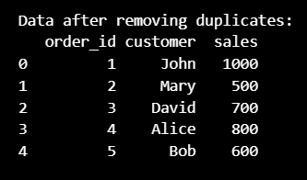

import sqlite3
connection = sqlite3.connect("historical_new_data.db")
combined_data.to_sql(
"orders",
connection,
if_exists="replace",
index=False)
print("Historical and new data loaded into database!")
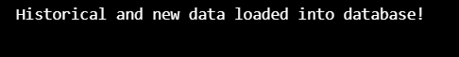

query = """
SELECT customer,
SUM(sales) AS total_sales
FROM orders
GROUP BY customer
"""
final_report = pd.read_sql_query(
query,
connection
)
print("Final Report:")
print(final_report)
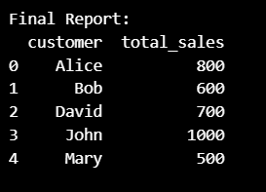

connection.close()
print("Historical + New Data Pipeline Completed!")
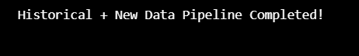

Practical-10

End-to-End E-Commerce Data Engineering Pipeline

Aim
To design and implement an end-to-end data engineering pipeline for an e-commerce dataset by performing data ingestion, data cleaning, data transformation, SQL database storage, data warehouse design, reporting, and visualization using Python, Pandas, SQLite, and Matplotlib.

Code

import pandas as pd
import sqlite3
import matplotlib.pyplot as plt
1. DATA INGESTION

# Customers
customers = pd.DataFrame({
"customer_id": [1, 2, 3, 4, 5],
"customer_name": ["John", "Mary", "David", "Alice", "Bob"],
"city": ["Mumbai", "Delhi", "Pune", "Mumbai", "Chennai"]
})
# Products
products = pd.DataFrame({
"product_id": [101, 102, 103, 104, 105],
"product_name": [
"Laptop",
"Phone",
"Tablet",
"Headphones",
"Keyboard"
],
"category": [
"Electronics",
"Electronics",
"Electronics",
"Accessories",
"Accessories"
],
"price": [60000, 30000, 20000, 3000, 1500]
})

# Orders
orders = pd.DataFrame({
"order_id": [1001, 1002, 1003, 1004, 1005],
"customer_id": [1, 2, 3, 4, 5],
"product_id": [101, 102, 103, 104, 105],
"quantity": [1, 2, 1, 3, 2]
})

# Payments
payments = pd.DataFrame({
"payment_id": [501, 502, 503, 504, 505],
"order_id": [1001, 1002, 1003, 1004, 1005],
"payment_status": [
"Paid",
"Paid",
"Paid",
"Pending",
"Paid"
]
})

print("========== DATA INGESTION ==========")

print("\nCustomers:")
display(customers)

print("\nProducts:")
display(products)

print("\nOrders:")
display(orders)

print("\nPayments:")
display(payments)

# 2. SAVE DATA AS CSV FILES

customers.to_csv("customers.csv", index=False)
products.to_csv("products.csv", index=False)
orders.to_csv("orders.csv", index=False)
payments.to_csv("payments.csv", index=False)

print("\nAll CSV files created successfully!")

# 3. DATA CLEANING

print("\n========== DATA CLEANING ==========")
# Check missing values
print("\nMissing values in Customers:")
print(customers.isnull().sum())
print("\nMissing values in Products:")
print(products.isnull().sum())
print("\nMissing values in Orders:")
print(orders.isnull().sum())
print("\nMissing values in Payments:")
print(payments.isnull().sum())

# Remove duplicate records

customers = customers.drop_duplicates()
products = products.drop_duplicates()
orders = orders.drop_duplicates()
payments = payments.drop_duplicates()
print("\nDuplicates removed successfully!")

# Check data types
print("\nCustomers Data Types:")
print(customers.dtypes)
print("\nProducts Data Types:")
print(products.dtypes)

print("\nOrders Data Types:")
print(orders.dtypes)
print("\nPayments Data Types:")
print(payments.dtypes)

# Display cleaned datasets

print("\nCleaned Customers:")
display(customers)

print("\nCleaned Products:")
display(products)

print("\nCleaned Orders:")
display(orders)

print("\nCleaned Payments:")
display(payments)

# 4. DATA TRANSFORMATION

print("\n========== DATA TRANSFORMATION ==========")

# Join Orders and Products

order_data = orders.merge(
products,
on="product_id",
how="inner"
)

print("\nOrders + Products:")
display(order_data)

# Calculate total sales

order_data["total_sales"] = (
order_data["price"] *
order_data["quantity"]
)

print("\nTotal Sales Calculated:")
display(order_data)

# Add customer information

order_data = order_data.merge(
customers,
on="customer_id",
how="inner"
)

print("\nAdded Customer Information:")
display(order_data)

# Add payment information

order_data = order_data.merge(
payments,
on="order_id",
how="inner"
)

print("\nFinal Transformed Dataset:")
display(order_data)

# 5. SALES SUMMARY

sales_summary = order_data.groupby("category").agg(
total_sales=("total_sales", "sum"),
total_quantity=("quantity", "sum")
).reset_index()

print("\nSales Summary by Category:")
display(sales_summary)

# 6. CREATE SQL DATABASE

print("\n========== SQL DATABASE STORAGE ==========")

connection = sqlite3.connect(
"ecommerce_warehouse.db"
)

print("Database created successfully!")

# 7. STORE TABLES IN DATABASE

customers.to_sql(
"dim_customer",
connection,
if_exists="replace",
index=False
)
products.to_sql(
"dim_product",
connection,
if_exists="replace",
index=False
)
orders.to_sql(
"orders",
connection,
if_exists="replace",
index=False
)

payments.to_sql(
"payments",
connection,
if_exists="replace",
index=False
)
order_data.to_sql(
"fact_sales",
connection,
if_exists="replace",
index=False
)
print("All tables stored in the database!")
# 8. DISPLAY DATABASE TABLES
print("\nCustomer Dimension:")
display(
pd.read_sql_query(
"SELECT * FROM dim_customer",
connection
)
)
print("\nProduct Dimension:")
display(
pd.read_sql_query(
"SELECT * FROM dim_product",
connection
)
)
print("\nFact Sales:")
display(
pd.read_sql_query(
"SELECT * FROM fact_sales",
connection
)
)

# 9. CHECK DATABASE TABLES
tables = pd.read_sql_query(
"""
SELECT name
FROM sqlite_master
WHERE type='table'
""",
connection
)
print("\nTables in Data Warehouse:")
display(tables)
# 10. DATE DIMENSION
date_data = pd.DataFrame({
"date_id": [1, 2, 3, 4, 5],
"date": [
"2026-01-01",
"2026-01-02",
"2026-01-03",
"2026-01-04",
"2026-01-05"
],
"year": [2026, 2026, 2026, 2026, 2026],
"month": [1, 1, 1, 1, 1]
})
print("\nDate Dimension:")
display(date_data)
date_data.to_sql(
"dim_date",
connection,
if_exists="replace",
index=False
)
print("Date dimension created successfully!")
# 11. REPORTING - TOTAL SALES
print("\n========== REPORTING ==========")
query = """
SELECT SUM(total_sales) AS total_sales
FROM fact_sales
"""
total_sales_report = pd.read_sql_query(
query,
connection
)

print("\nTotal Sales:")
display(total_sales_report)
# 12. SALES BY CATEGORY
query = """
SELECT category,
SUM(total_sales) AS total_sales
FROM fact_sales
GROUP BY category
"""
category_report = pd.read_sql_query(
query,
connection
)
print("\nSales by Category:")
display(category_report)
# 13. SALES BY CUSTOMER

query = """
SELECT customer_name,
SUM(total_sales) AS total_sales
FROM fact_sales
GROUP BY customer_name
"""
customer_report = pd.read_sql_query(
query,
connection
)
print("\nSales by Customer:")
display(customer_report)
# 14. PAYMENT REPORT
query = """
SELECT payment_status,
COUNT(*) AS number_of_orders,
SUM(total_sales) AS total_sales
FROM fact_sales
GROUP BY payment_status
"""
payment_report = pd.read_sql_query(
query,
connection
)

print("\nPayment Report:")
display(payment_report)

# 15. DATA VISUALIZATION
plt.figure(figsize=(8, 5))
plt.bar(
category_report["category"],
category_report["total_sales"]
)
plt.title("Sales by Product Category")
plt.xlabel("Category")
plt.ylabel("Total Sales")
plt.show()
# 16. FINISH THE PIPELINE
print("\n====================================")
print("END-TO-END DATA ENGINEERING PROJECT")
print("====================================")

print("✓ Data Ingestion")
print("✓ Data Cleaning")
print("✓ Data Transformation")
print("✓ SQL Storage")
print("✓ Data Warehouse Design")
print("✓ Reporting")
print("✓ Visualization")
print("\nPROJECT COMPLETED SUCCESSFULLY!")
# Close database connection
connection.close()

